IDENTITY AND ACCESS MANAGEMENT (IAM) IN AWS

IAM (IDENTITY AND ACCESS MANAGEMENT)
It refers to a framework or policies and technologies for ensuring that the proper people in an organisation have the appropriate access to the technology resources.
- AWS Identity and Access Management (IAM) is a web service that provides secure access to AWS resources.
- we can use IAM to control who is authenticated (signed-in) and authorised (has permission) to use resources.
- It allows you to manage users, groups, and permissions to control who can access which resources in your AWS account.
- when we create a account you begin with a single sign-in identity that has completely access to all aws services and resources in account.
- this identity is called aws account "root user" and accessed by sign-in with the email address or password.
- but aws recommend that you don't use root user for everyday task even the administrative once's.
- use other IAM account to manage the administrator task of your account and secured lock away the root user credential and use them to perform only a few account and service management task.
AWS Identity and Access Management is a web service that you securely control access to AWS resources. We use IAM to control who is authenticated (signed-in) and authorized (has permission) to use resources.

IAM USER
- IAM User is an identity in Amazon Web Services that represents a person or application needing access to AWS.
- Each IAM User has unique credentials like a username/password (for console) or access key & secret key (for API/CLI access).
- By default, a new IAM User has no permissions, and you must assign permissions using IAM policies or groups.
- IAM Users belong to a single AWS account, and all usage is billed to the parent account, not the user.
- By default, we can create up to 5000 users per aws account.
- And create upto 10 users at a time.

IAM GROUPS
- IAM Group is a collection of IAM Users in Amazon Web Services used to manage multiple users together.
- an IAM group is an identity in IAM that specify collection of IAM user.
- we can add no of users in a group so that we can specify permission for multiple users at a same time.
- group make permission easier to manage for large set of users.
- By default, we can create upto 300 groups in an AWS account.
- And a user can be a member of up to 10 IAM groups.

IAM ROLE
- IAM role is an identity in IAM that we create in our own account that have the specific permission.
- IAM role in aws works like a IAM user.
- IAM Role is an identity in Amazon Web Services with specific permissions, similar to an IAM user but used differently.
- IAM Role does not have permanent credentials (no password or access key); it provides temporary security credentials when assumed.
- Roles are assumed by users, applications, or services to perform actions (e.g., an EC2 instance accessing S3).
- IAM Roles are used for secure access scenarios like cross-account access, AWS services (service roles), or external users (federation/web identity).
- By default we can create upto 1000 IAM roles.

TYPES OF IAM ROLES
- AWS Service Role
Used by AWS services (like EC2, Lambda) to access other AWS resources.
- SAML 2.0 federation
Used for enterprise login (SSO) via identity providers like Active Directory.
- AWS Cross-Account Role
Allows one AWS account to access resources in another AWS account.
- Web Identity Role
Used for external users via providers like Google, Facebook (OIDC).
- Custom trust policy

POLICIES
- An policy is an object in AWS where is associate with an entity or resources define their permission.
- the permission in the policies that determines whether the request is allowed or denied.
- most policies are stored in AWS as JSON documents.
- a policy defines the permissions to the IAM identity.

TYPES OF POLICIES (Where they are used)
- Identity Based Policies
  - Attached to users, groups, or roles
  - Define what actions they can perform

- Resources Based Policies
  - Attached directly to a resource (like S3 bucket)
  - Define who can access that resource

- Permission Boundary
  - Sets the maximum permissions limit for a user or role
  - Even if more permissions are given, they cannot exceed this limit

- Session Policy
  - Temporary policies applied during a role session
  - Further restrict permissions for that session

- ACLs (Access Control List)
  - Used mainly in services like S3
  - Define basic permissions (read/write) at resource level

- SCPs (Service Control Policies)
  - Used in AWS Organizations
  - Control permissions across multiple AWS accounts

WHAT ARE THE WAYS TO ATTACHED POLICY TO A USER
- add user into the group
- copy permissions of existing user
- attach directly

TYPES OF POLICIES (Who created them)
Aws Managed Policies
- AWS managed policies are predefined policies created and maintained by AWS.
- They are designed to provide common permissions needed for specific AWS services or tasks
- These policies are accessible across multiple AWS accounts and regions.
- AWS managed policies cannot be edited, and their permissions are managed by AWS.
- You can directly attach AWS managed policies to IAM identities (users, groups, or roles) or use them as a reference in a custom policy.

Customer Policy
- Custom managed policies are policies that you create and manage yourself.
- They offer flexibility in defining fine-grained permissions tailored to your specific requirements.
- Custom managed policies are attached to IAM identities (users, groups, or roles) to grant permissions.
- They can be edited, updated, and version-controlled according to your needs.
- custom managed policies require manual updates to incorporate new services or changes.

Inlined policy
- Inlined policies are useful for granting specific permissions to an individual user, group, or role without the need to create a separate managed policy.
- Inlined policies are written in JSON format and provide explicit permissions for the associated entity.
- An inlined policy is an IAM policy that is directly attached to an IAM user, group, or role.
- Inlined policies are defined and managed within the IAM entity to which they are attached.

BOUNDARY PERMISSION
- Boundary permissions, also known as a boundary policy, are used to set the maximum permissions that can be granted to an IAM entity (user, group, or role).
- A boundary permission is an IAM policy that is attached to an IAM entity.
- When a boundary policy is assigned to an IAM entity, it restricts the permissions that can be granted to that entity through other means, such as inlined policies or managed policies.
- When a boundary policy is assigned to an IAM entity, it restricts the permissions that can be granted to that entity through other means, such as inlined policies or managed policies.
- Boundary policies are useful for enforcing least privilege principles and preventing excessive permissions from being granted to IAM entities.

HOW TO CREATE A USER
- Click Users → Create user
- Enter username -----> mayur
- Select access type (Console / Programmatic)
- Attach permissions (group or policy)
- Click Create user
- Download credentials

HOW TO CREATE A GROUP
- Click User groups → Create group
- Enter Group name ----> tech
- Attach permissions (policies)
- Add users (optional)
- Click Create group

HOW TO CREATE A ROLE
- Got to IAM service
- Click Roles → Create role
- Select AWS service
- Choose EC2
- Attach permissions (policies) -----> AdministratorAccess
- Enter Role name -----> Role-For-EC2
- Create role

HOW TO CREATE A INLINED POLICY
VISUAL FORMAT
- click on user
- click on add permissions
- create a inlined policy
- choose policy type – Jason/visual/
- select service – s3
- Actions → Select (e.g., GetObject, PutObject)
- Resources → Choose specific bucket or all
- policy name → my-inlined-policy
- create a policy

IN JASON FORMAT
{
"Version": "2012-10-17",
"Statement": [
{
"Effect": "Allow",
"Action": "s3:ListBucket",
"Resource": "*"
}
]
}
Note:
- This policy is directly attached to a user so if the user is deleted the policy is also deleted
- This policy we can attach to a user / group / role

ACCESS S3 USING IAM ROLE
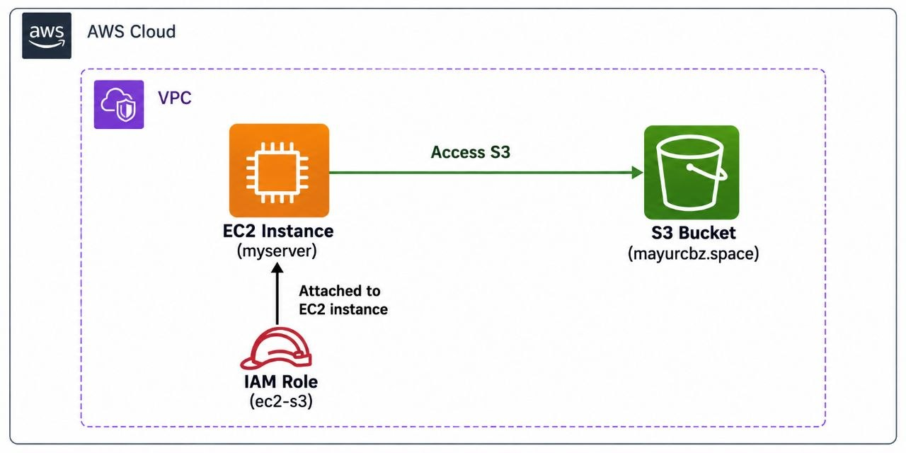
create a server
- name - myserver
- instance_type - t3.micro
- key_name - mayur.pem
- sg - mysg
- create a server
create a s3 bucket
- name - mayurcbz.space
create a Iam role (ec2-s3)
- search and click on IAM service
- create a role
- choose - aws-service
- permission - s3fullAccess
- create a role
Assign role to server
- click on server
- click on action
- click on security
- click on modify iam role
- select-role - (ec2-s3)
- update
Access the server
- apt update
- snap install aws-cli --classic
- aws s3 ls

